**An InternPulse Project**

**A Business Day Web Scraping and Sentiment Analysis Report**

By

**Data Analyst Track – Group 2**

**Group Members:** Oluoma Ilobah, Oluwaseun Omotehinse, Nafisat Lawal

**Project Overview**

This project is aimed at scraping articles from Business Day website to carryout sentiment analysis in order to understand the emotional tone expressed in articles published from 2021 to 2015. The key focus is to provide insight into how the economic narrative of Nigeria has evolved overtime through media coverage.

**Key Objectives:**

* To understand Public Mood and Emotional Climate.
* To track sentiment trends from 2021 – 2025.
* To measure media framing the nation’s economy within the period under review.

**About Business Day**

Business Day is a leading Nigerian business and financial daily newspaper. Business Day serves a diverse readership including policymakers, business leaders, investors, and professionals. It's reputation for credible journalism and its focus on data-driven reporting make it an influential voice in shaping public and economic discourse in Nigeria. Thus, being our data source on Nigeria's economic matters.

By analyzing the emotional tone of the national media we uncover critical insights into the collective mood, public sentiment, and underlying economic and social tensions within the country.

**Project Methodology:**

**1. Methodology**

* Data collection: scraping of BusinessDay articles:[<https://businessday.ng/tag/bdlead/?amp>]
  + Scraped 819 BusinessDay articles from 2021 - 2025
* Preprocessing steps: *Data cleaning, tokenization, removed stop works
* Scraping Tool used: **Selenium**

**Features Extracted**

* Title
* Author
* Date published
* Full articles' contents

**2. Preprocessing & Sentiment Analysis** **Preprocessing**

* Removed stopwords, and punctuation

* Converted text to lowercase

* Carried out tokenization and lemmatization

**Sentiment Model**

* Tool Used: TextBlob

**Tools & Libraries**

* Python 3.13
* Selenium
* Pandas
* NLTK, TextBlob
* Matplotlib, Seaborn

**Polarity Scores are categorized into the following:**

* Positive
* Neutral
* Negative

**Key Findings:**

* Overall, about 6,604 articles were scraped; and 1312 articles which accounts for 20% tended towards a Positive emotional tone, implying a good outlook of the nation's economy by this chunk.
* While, 78% was Neutral, indicating middle positioning of emotional tone of the articles(neither positive nor negative).
* Only about 2% was Negative.

**See schematics below:**

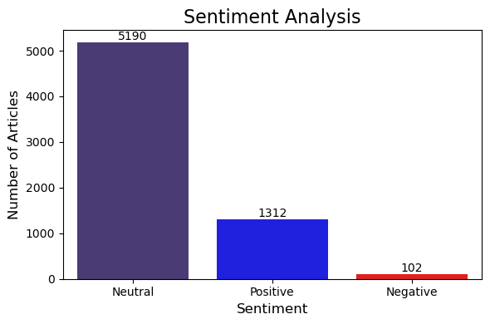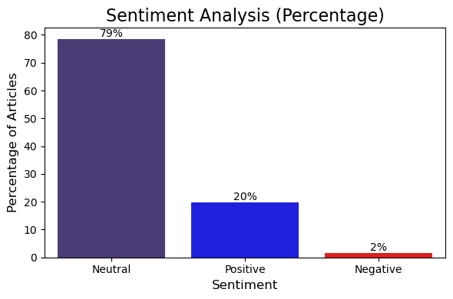

**Polarity Scores across the 5years (2021 -2015) under review**

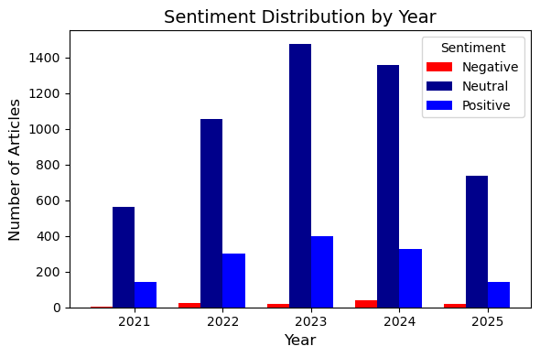

* From the schematics above, it is further revealed that most of the articles had Neutral tone, followed by Positive and the least, Negative.
* This further implies that majority of the articles were balanced or emotionally subdued without leaning toward either optimism or pessimism.
* Only a chunk of 20% depicted optimism and favourable emotional tone.
* And a rather insignificant percentage of the articles reflected a pessimistic, critical, or concerned emotional tone regarding the economic affairs of the nation.

Following the resuts of our findings, which shows a larger percentage of Neutral emotional tone of the media channel on the nation’s economic landscape, we recommend the following:

* **The need to deepen economic narratives**: Encourage analysts, economists, and media to connect **policy updates to real-world impact** (e.g., “What this CBN reform means for SMEs”).
* **A more strategic approach to stimulating public confidence**: Government and institutions should use clear communication to **boost confidence**—highlighting small wins, showcasing local success stories.
* **Monitor for Tipping Points**: Watch for sentiment shifts around key economic indicators (GDP releases, subsidy removals, forex policy changes), and be ready to respond to **public reactions or backlash**.
* **Align Messaging with Data**: Emphasize transparency in data (e.g., inflation trends, debt servicing) while using **narratives that highlight resilience and recovery**.
* **Activate Stakeholders**: Businesses, investors, and civic groups should be encouraged to **take more visible roles** in public discourse—op-eds, forums, and roundtables—to spark meaningful conversation around national direction.

**In Conclusion:**

A predominantly **Neutral tone** in media like BusinessDay often reflects an economy in **stable but cautious motion**. It calls for **clearer messaging**, **stronger engagement**, and **closer monitoring** of emotional shifts to effectively guide public perception and policy alignment.